PERANCANGAN PCB
ROBOT WELDING ARM MANIPULATOR 6-DOF



Dirancang Oleh :
Alfonsus Giovanni Mahendra Putra / Teknik Listrik Industri / 40040621650042

DEPARTEMEN TEKNOLOGI INDUSTRI
FAKULTAS SEKOLAH VOKASI
UNIVERSITAS DIPONEGORO
2024
PCB KONTROLER UTAMA

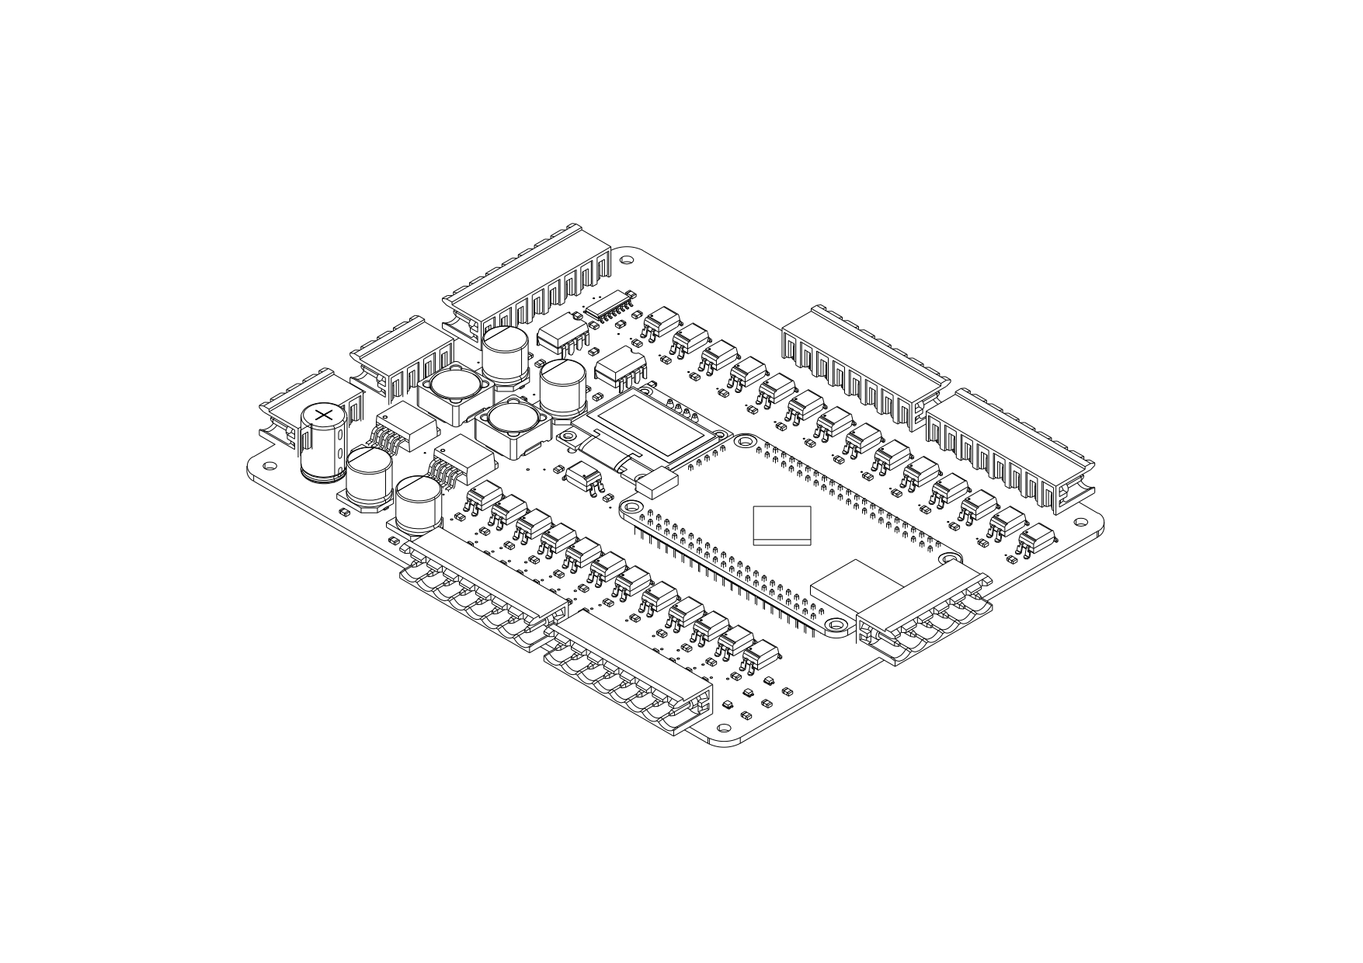

Spesifikasi:

- Microcontroller STM32H743VIT6
- 24VDC Supply
- 5VDC and 3,3VDC Output
- Dual Emergency Stop
- 18 Channels Digital Input
- 12 Channels Digital Output
- RS-232 Communication
- OLED LCD Interface

SCHEMATIC DIAGRAM PCB KONTROLER UTAMA
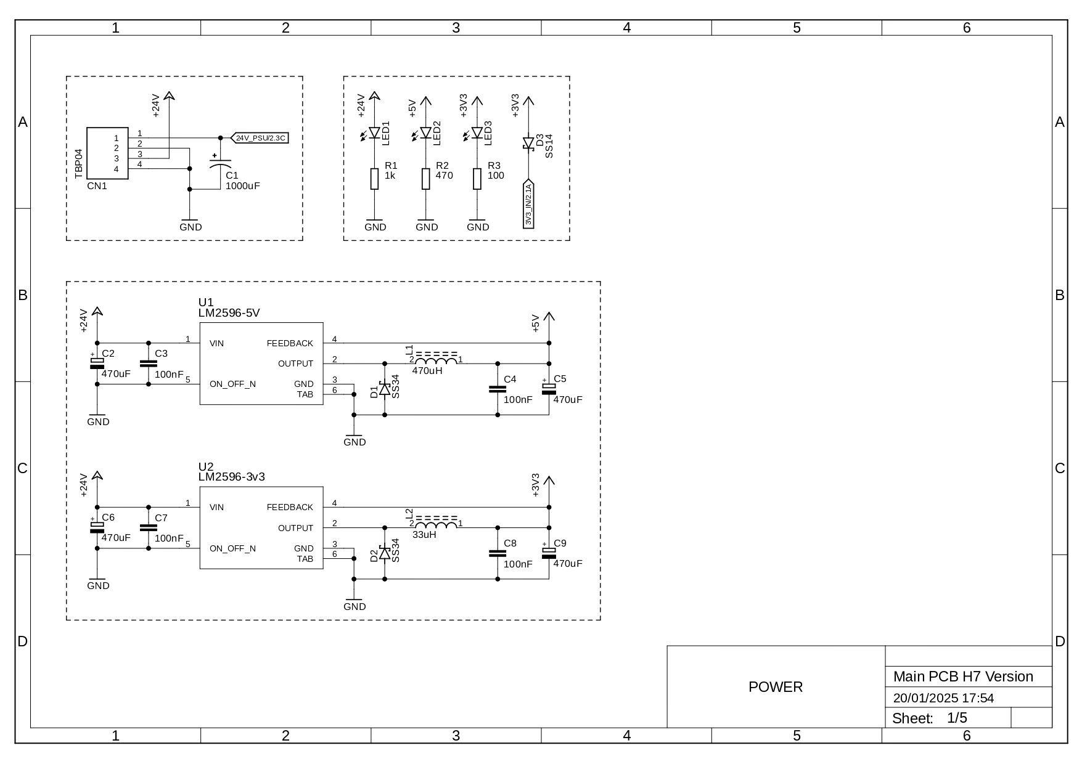
SCHEMATIC DIAGRAM PCB KONTROLER UTAMA
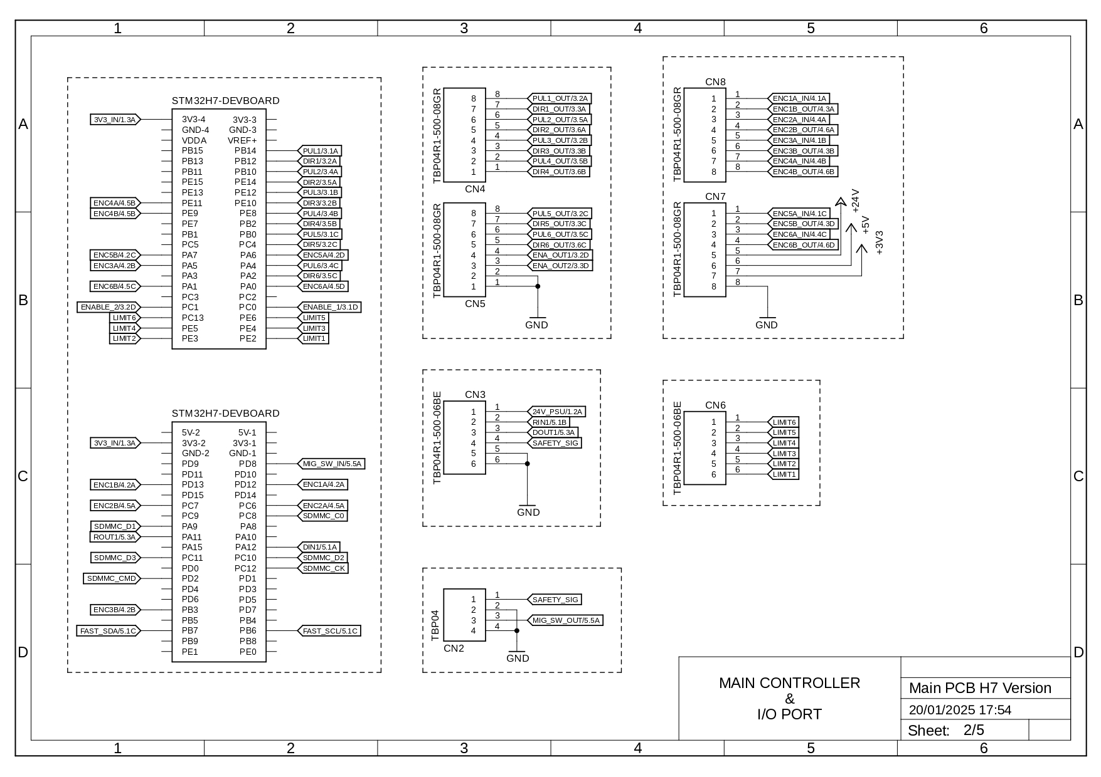
SCHEMATIC DIAGRAM PCB KONTROLER UTAMA
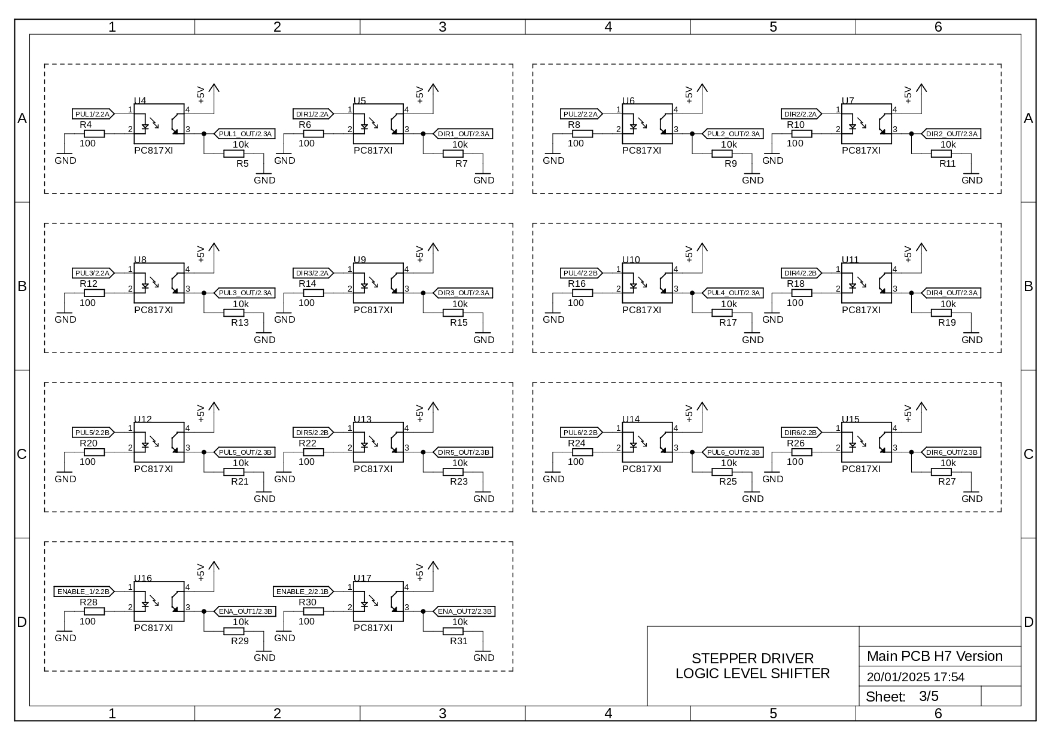
SCHEMATIC DIAGRAM PCB KONTROLER UTAMA
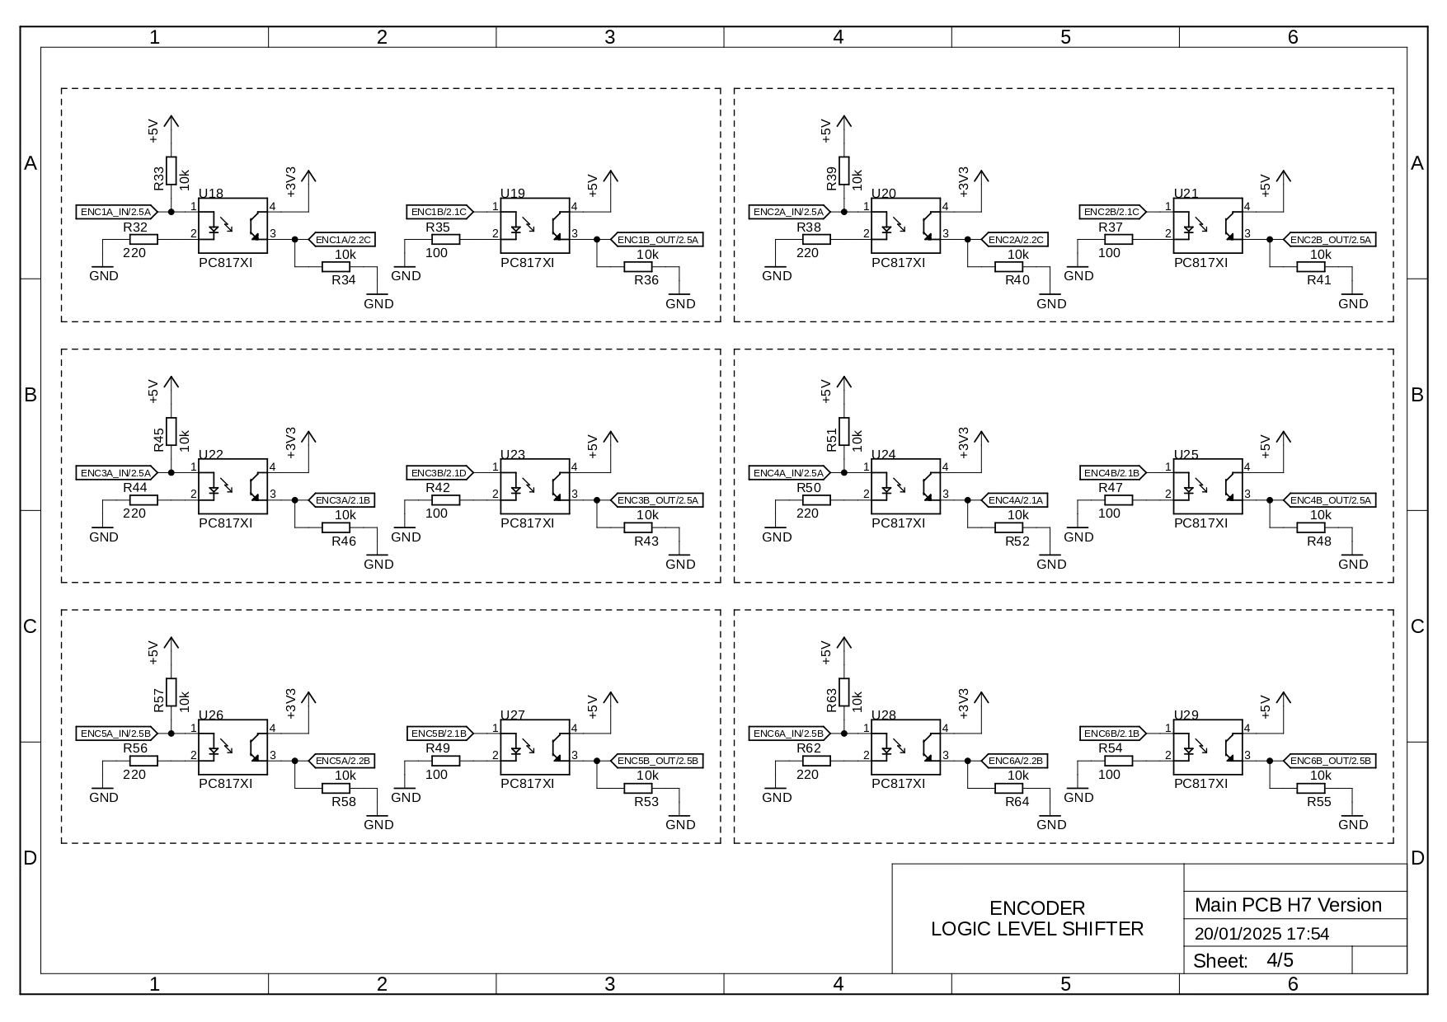
SCHEMATIC DIAGRAM PCB KONTROLER UTAMA
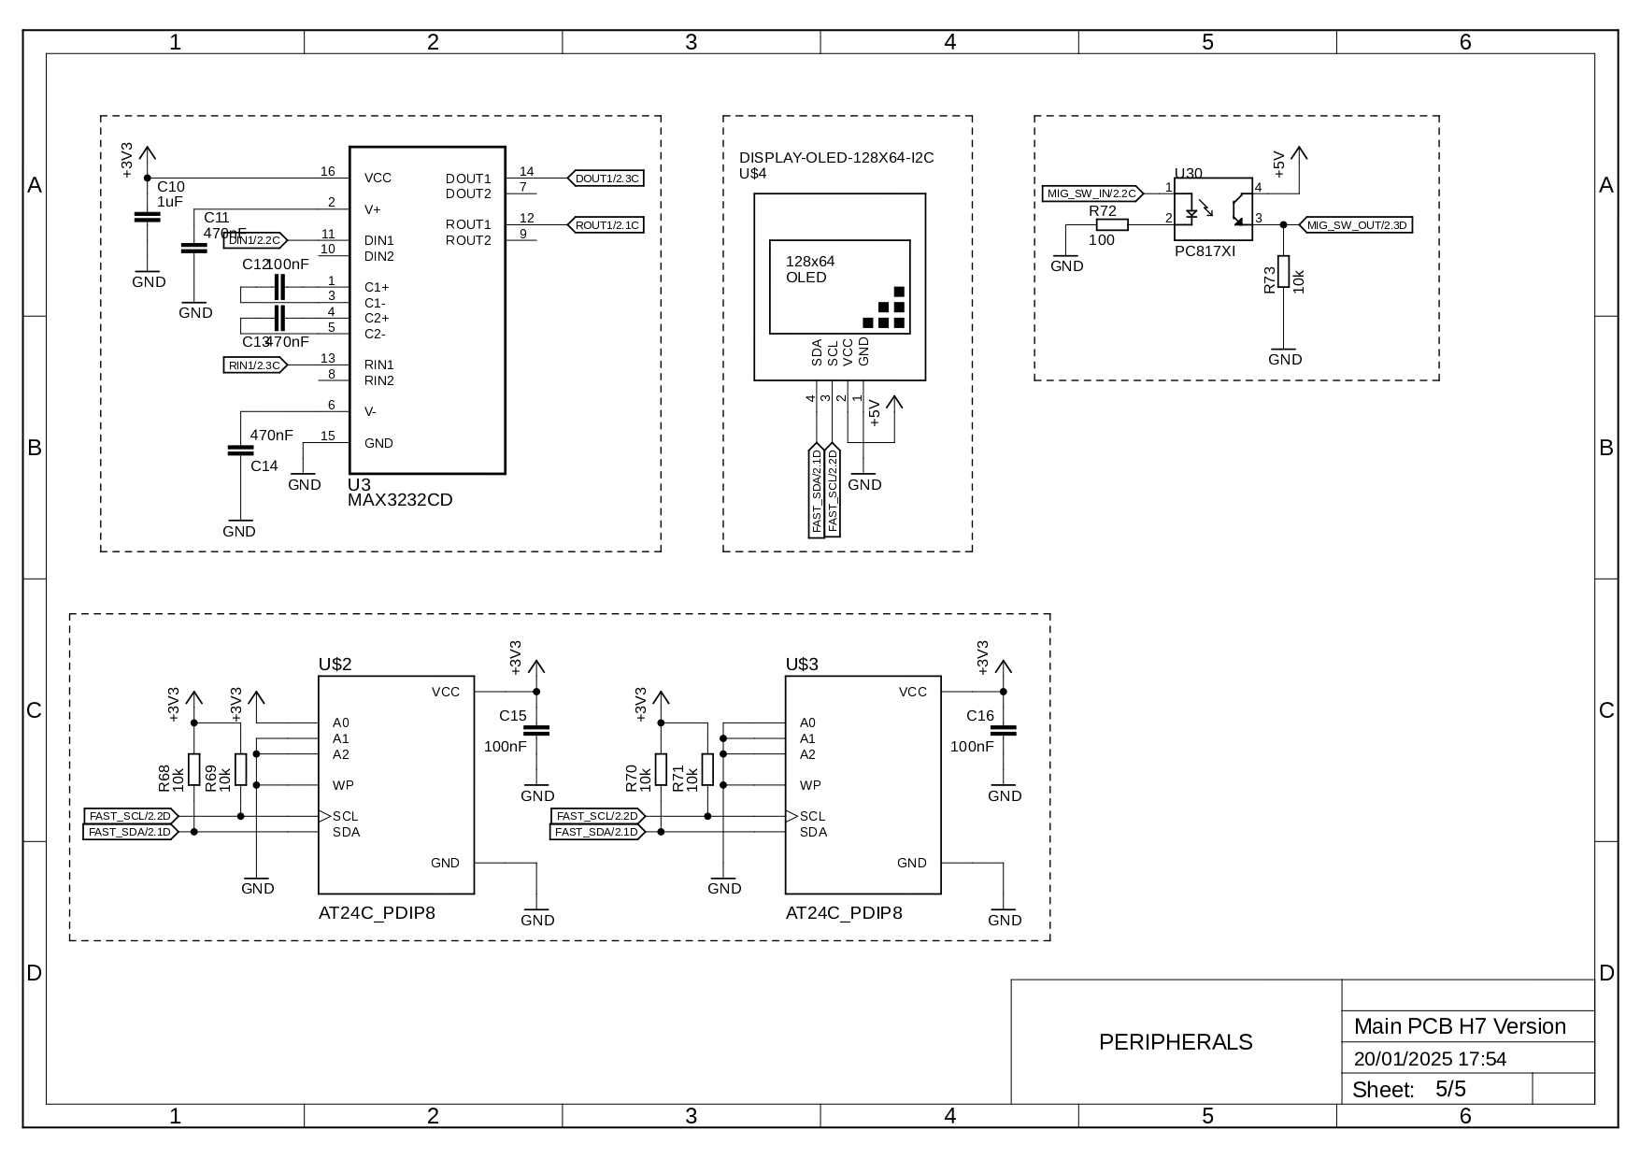
PCB TEACH PENDANT

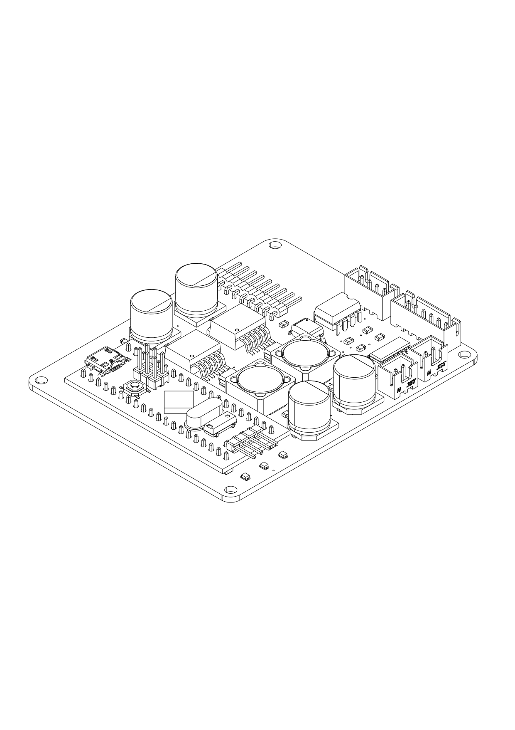

Spesifikasi:
- Mikrokontroler STM32F103C8T6
- 24VDC Supply
- On/Off Selector Switch
- Interface LCD 20x4
- Keypad Matrix 5x4
- Emergency Stop
SCHEMATIC DIAGRAM PCB TEACH PENDANT
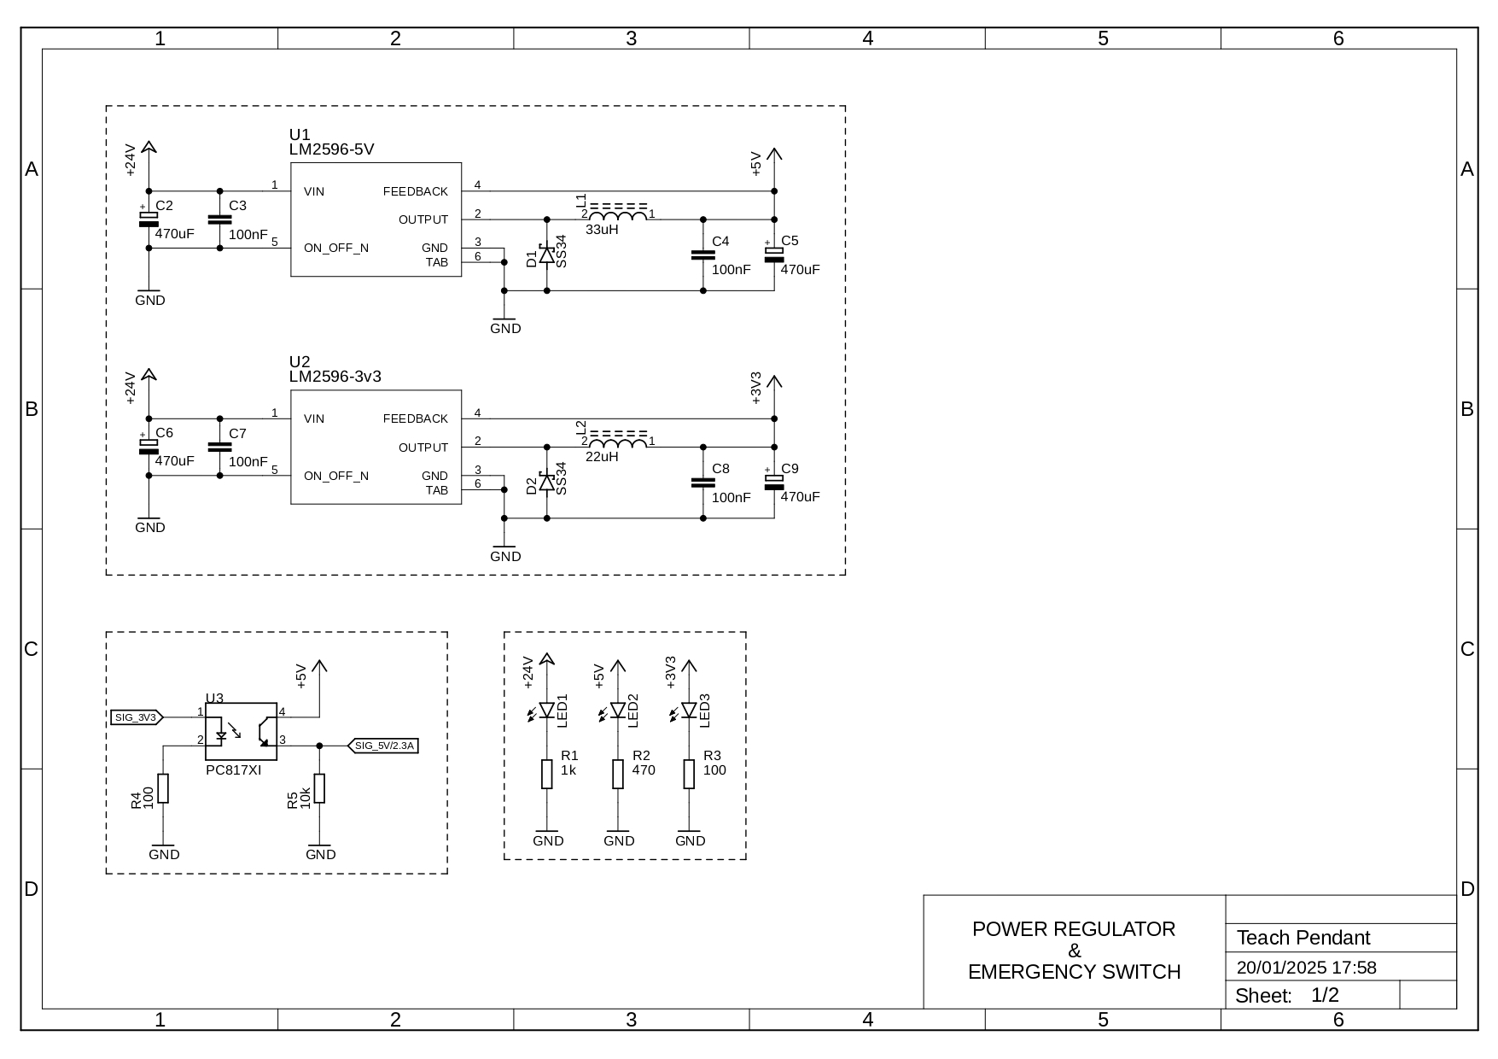
SCHEMATIC DIAGRAM PCB TEACH PENDANT
